COLLECTION EXERCISE
G. AAMNA KHAN
192371084
- Library Book Management
import java.util.*;
public class Main {
public static void main(String[] args) {

HashSet<Book> books = new HashSet<>();

books.add(new Book("101", "Java", "James", 2020));
books.add(new Book("102", "Python", "Guido", 2023));
books.add(new Book("103", "C", "Dennis", 2018));

Iterator<Book> it = books.iterator();
while (it.hasNext()) {
Book b = it.next();
if (b.isbn.equals("103")) {
it.remove();
}
}

ArrayList<Book> list = new ArrayList<>(books);

Collections.sort(list, (a, b) -> b.year - a.year);

System.out.println("Books:");
Iterator<Book> itr = list.iterator();
while (itr.hasNext()) {
Book b = itr.next();
System.out.println(b.isbn + " " + b.title + " " + b.author + " " + b.year);
}

System.out.println("\nBooks by James:");
for (Book b : books) {
if (b.author.equals("James")) {
System.out.println(b.title);
}
}
}
}
class Book {
String isbn, title, author;
int year;

Book(String isbn, String title, String author, int year) {
this.isbn = isbn;
this.title = title;
this.author = author;
this.year = year;
}
}
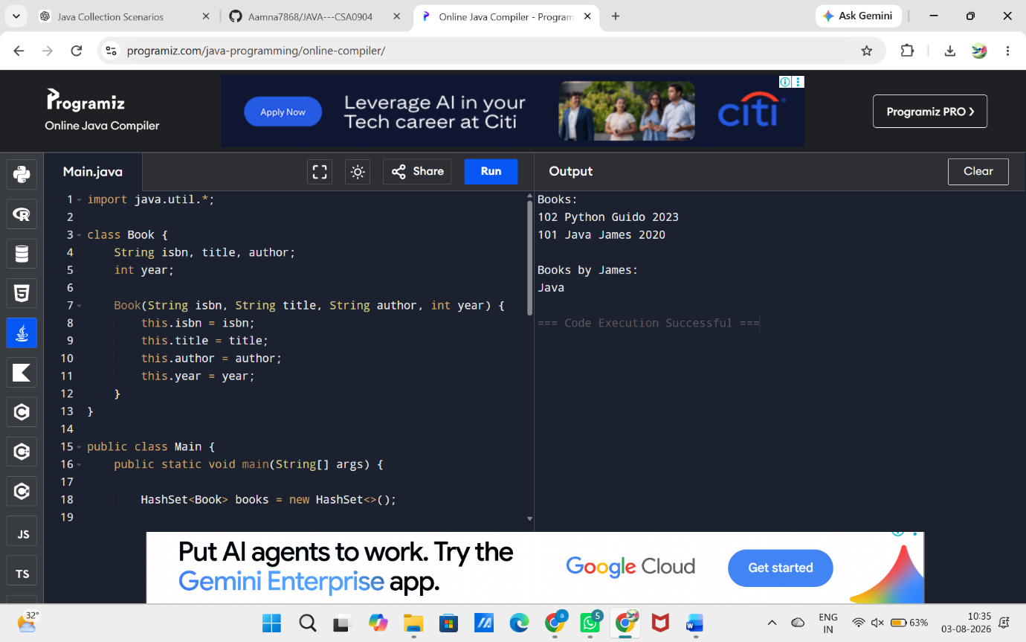
2. Student Grade Analyzer
import java.util.*;
public class Main {
public static void main(String[] args) {

ArrayList<Student> list = new ArrayList<>();

Student s1 = new Student(1, "Aman");
s1.grades.put("Math", 90);
s1.grades.put("Science", 80);

Student s2 = new Student(2, "Rahul");
s2.grades.put("Math", 20);
s2.grades.put("Science", 30);
s2.grades.put("English", 35);

Student s3 = new Student(3, "Neha");
s3.grades.put("Math", 95);
s3.grades.put("Science", 92);

list.add(s1);
list.add(s2);
list.add(s3);

Iterator<Student> it = list.iterator();
while (it.hasNext()) {
if (it.next().failCount() > 2)
it.remove();
}

Collections.sort(list, (a, b) -> Double.compare(b.average(), a.average()));

System.out.println("Top Students");
for (Student s : list) {
System.out.println(s.id + " " + s.name + " " + s.average());
}
}
}
class Student {
int id;
String name;
HashMap<String, Integer> grades = new HashMap<>();

Student(int id, String name) {
this.id = id;
this.name = name;
}

double average() {
int sum = 0;
for (int g : grades.values())
sum += g;
return sum / (double) grades.size();
}

int failCount() {
int count = 0;
for (int g : grades.values())
if (g < 40)
count++;
return count;
}
}
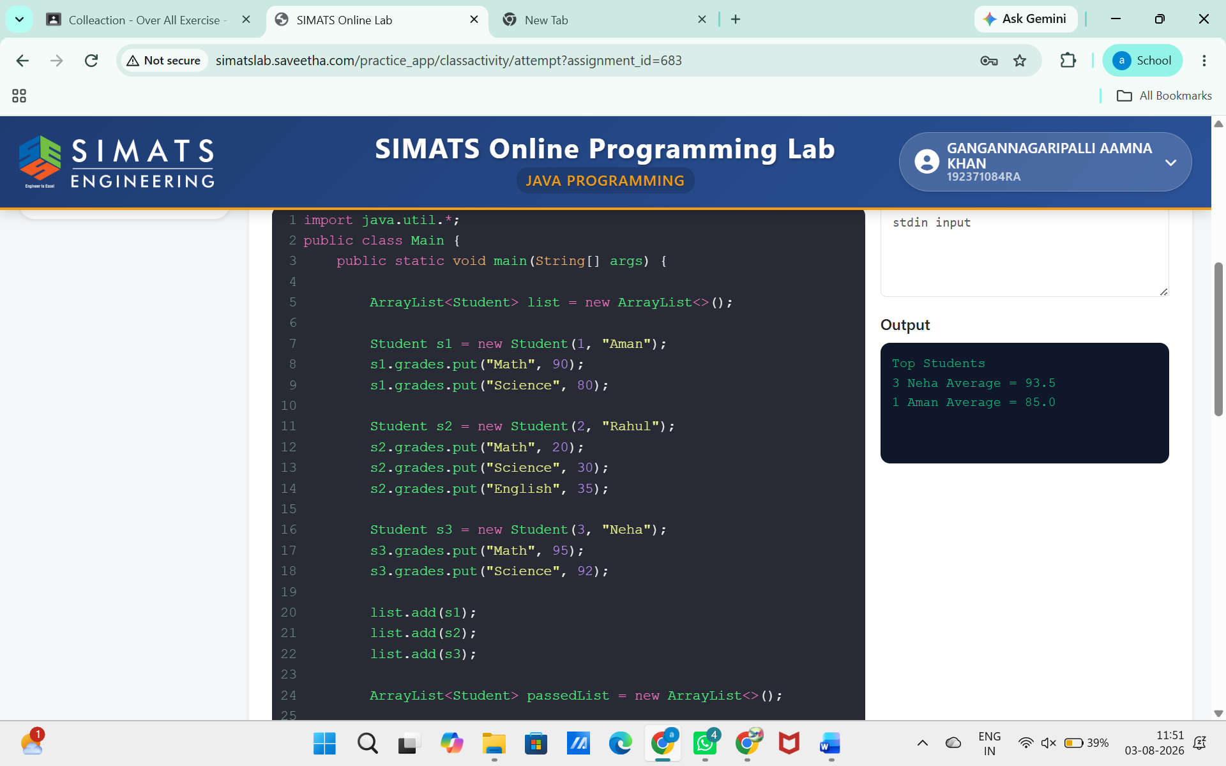
3.Navigation History
import java.util.*;

public class Main {

public static void main(String[] args) {

Stack<String> back = new Stack<>();
Stack<String> forward = new Stack<>();

String current = "google.com";

back.push(current);

current = "youtube.com";
back.push(current);

current = "github.com";

if (!back.isEmpty()) {
forward.push(current);
current = back.pop();
}
if (!forward.isEmpty()) {
back.push(current);
current = forward.pop();
}

System.out.println("Current Page: " + current);

System.out.println("Back History");
Iterator<String> it = back.iterator();
while (it.hasNext())
System.out.println(it.next());

System.out.println("Forward History");
Iterator<String> itr = forward.iterator();
while (itr.hasNext())
System.out.println(itr.next());
}
}
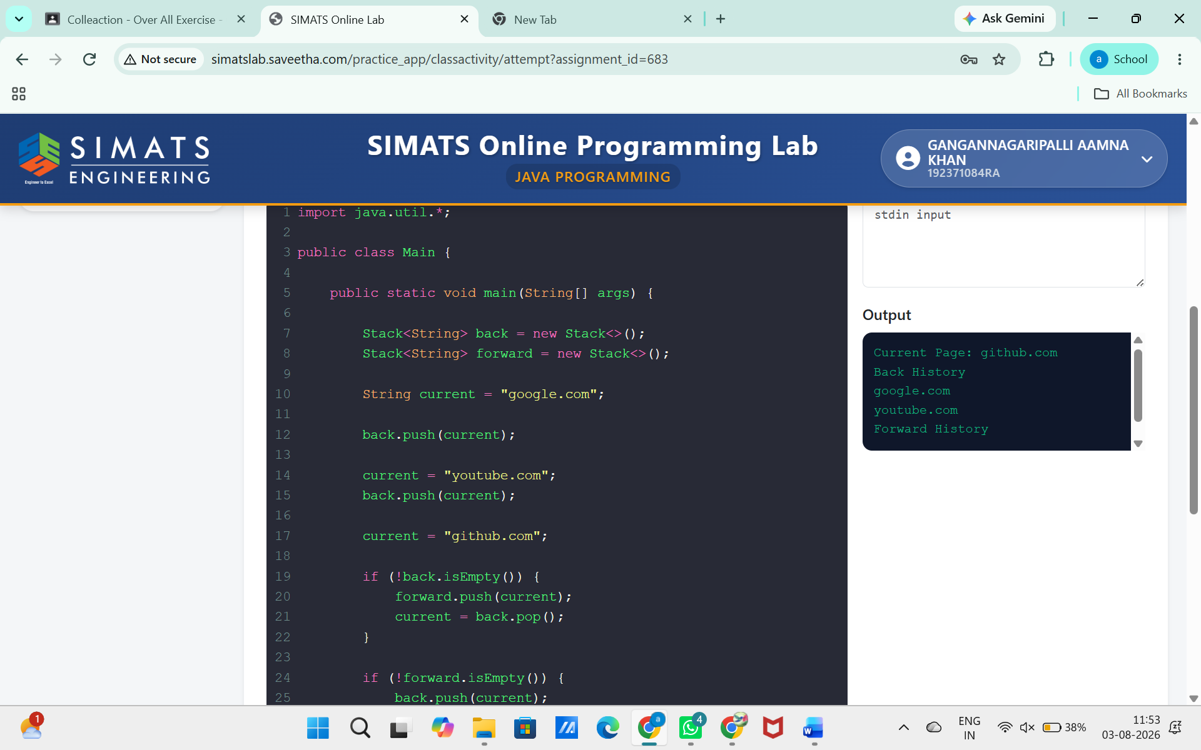
4. Employee Payroll System
import java.util.*;

public class Main {

public static void main(String[] args) {

HashMap<String, List<Employee>> map = new HashMap<>();

map.put("IT", new ArrayList<>());
map.put("HR", new ArrayList<>());

map.get("IT").add(new Employee(1, "Aman", "IT", 50000));
map.get("IT").add(new Employee(2, "Rahul", "IT", 30000));
map.get("HR").add(new Employee(3, "Neha", "HR", 60000));

Iterator<Map.Entry<String, List<Employee>>> it = map.entrySet().iterator();

while (it.hasNext()) {

Map.Entry<String, List<Employee>> entry = it.next();

double total = 0;
Employee max = null;

Iterator<Employee> itr = entry.getValue().iterator();

while (itr.hasNext()) {

Employee e = itr.next();

total += e.salary;

if (e.salary < 40000)
itr.remove();

if (max == null || e.salary > max.salary)
max = e;
}

System.out.println("Department: " + entry.getKey());
System.out.println("Total Salary: " + total);

if (max != null)
System.out.println("Highest Paid: " + max.name);

System.out.println("Employees:");
for (Employee e : entry.getValue()) {
System.out.println(e.id + " " + e.name + " " + e.salary);
}
System.out.println();
}
}
}
class Employee {
int id;
String name;
String dept;
double salary;

Employee(int id, String name, String dept, double salary) {
this.id = id;
this.name = name;
this.dept = dept;
this.salary = salary;
}
}
